|  |  |
| --- | --- |
| Product Name | Applied Degree in Software Engineering (BDSE) |
| Qualification Name | Applied Degree in Software Engineering |
| Product Name | Programming Foundations |
| Module Name (BDSE) | **Programming Foundations** |

|  |  |  |  |  |  |
| --- | --- | --- | --- | --- | --- |
| Learner name | | | Assessor name | | |
| Ida Bagus Ketut Yoghantara | | |  | | |
| Date issued | Completion date | | | | Submitted on |
| 8 June 2022 | 12 June 2022 | | | | 12 June 2022 |
|  | | | |  | |
| Project title | | Development of MCQ System | | | |

**Plagiarism**

Plagiarism covers both copying or paraphrasing with the source without proper understanding and citation. The source includes but is not limited to

• Books, Journal Articles, Online resources

• Others Assignment or project

• Software program

• Images

The learners must submit their work without plagiarism while producing the evidence against the assessment criteria. They must apply proper citation and Harvard referencing. Their work must go through the Turnitin software to check for the similarity index. Please consult the relevant module instructor or mentor if you need any further advice.

|  |
| --- |
| **Learner declaration** |
| I certify that the work submitted for this assignment is my own and research sources are fully acknowledged.  Student signature:  Date: 12 Jun 2022 |
|  |

Table of Contents

1. Introduction 3

2. Background 3

3. Algorithm 3

4. Programming Paradigms 4

5. Coding Standards 6

6. IDE 8

7. Project Design 9

8. Architecture 9

9. Implementation 9

# Introduction

Computer programming (often shortened to programming) is a process that leads from an original formulation of a computing problem to executable computer programs. Programming involves activities such as analysis, developing understanding, generating algorithms, verification of requirements of algorithms including their correctness and resources consumption, and implementation (commonly referred to as coding) of algorithms in a target programming language.

# Background

The background of this project is the company want to expanding their market into the Information Technology subject areas. The company want their internship to make and producing software development to assess the subject knowledge. As the internship, they want the internship to make them a MCQ System for the given scenario as below

1. The system should handle multiple sets of MCQs. For example, Java Basics, Control Structure, HTML Basics, etc.
2. After selecting the set, the system should display the questions from the selected list
3. Let the users answer and calculate the score based on their answer. For example, the score should be 90% when the user answers 9 questions correctly out of 10 questions.

# Algorithm

Algorithm is a technique or procedure that is used to solve a problem. It works by having your computer perform a series of prescribed actions that describe how to do something and your computer will execute it exactly the same way every time. An algorithm operates by following a set of instructions made up of inputs. Once it has followed all the inputs, it will see a result, also known as output.

Algorithm design for project scenario:

1. Take username input
2. Generate MCQ Set name by the CSV file name without the extension to the user
3. Take user input for selecting MCQ set
4. If user selecting non-existence MCQ set, give user a warning and repeat step 3
5. Display question and the multiple choice according to user input from selecting the MCQ set
6. Take user input for their answer
7. If user inputting non-existence multiple choice, give user a warning and repeat step 6
8. Compare user answer and correct answer from the CSV file
9. If user choose the correct answer, add user score by 1  
   else display the correct answer and count the wrong answer by 1 per wrong answer
10. Repeat from step 5 until the 10 questions from the CSV file answered by the user
11. Print the score multiple by 10 and display user name, user right answer counter, and user wrong answer counter

# Programming Paradigms

**Procedural Programming**

Procedural programming is a programming technique which derived from structured programming and also is based on the concept of invoking procedures. Procedures, often known as routines, subroutines, or functions, are essentially a set of instructions to be followed. Any procedure in a program can be invoked at any time during execution, either by other procedures or by the program itself.

Programming language which used to implement procedural programming are: FORTRAN, ALGOL, COBOL, BASIC, Pascal and C.

**Object Oriented**

Object-oriented programming (OOP) is a programming paradigm that is built around the concept of objects. Data is stored in the form of attributes, while code is stored in the form of methods. Computer programs are developed utilizing the concept of objects that interact with the real world entity in object-oriented programming. The most popular object-oriented programming languages are class-based, which means that objects are instances of classes, which also determine their types.

Programming language which used to implement Object Oriented are: Java, C++, C#, Python, PHP, JavaScript, Ruby, Perl, Objective-C, Dart, Swift, and Scala.

**Event Driven Paradigms**

The focus of event-driven programming is on events. Eventually, the program's flow is determined by occurrences. Until far, we've dealt with sequential or parallel execution models, but an asynchronous model is one that incorporates the concept of event-driven programming. An event loop that is always listening for new incoming events is required for event-driven programming. The success of event-driven programming is contingent on the occurrence of certain events. Once an event loops, it is up to the events to decide what to do and in what sequence to do it.

Programming language which used to implement Event Driven are: Visual Basic, C++ and Java.

**Programming paradigms used in this project is Object Oriented.**





Object Oriented features that used in this project is using the default constructor to make an object of MCQ to the main class. Using this object you can called the method from the object.

# Coding Standards

Coding Standards is some kind of rules that being used by all programmers. Rules that united all kind of things related to programming. Because every people have their own style, without standards the program will be difficult to learn by other programmer and will be hard to maintain and debug.

Common aspect of codding standards:

1. **Naming Conventions:**

- Meaningful and understandable variables, classes, interface, method and constants

- use pascal case, upper case, lower case at the right ones

**2. Source File**

- should be understandable named and structured

**3. Package and Import Statement**

- first non-comment line of most Java source files is a package statement.

**4. Classes and Function**

- specifies how classes and function should behave

**5. Commenting**

- Beginning comment: should begin with a c-style comment, include the programmer(s), date, copyright notice and a brief description

- Block comment, Single line comment, Trailing comment

**6. Indentation**

- Line length, wrapping line, method declaration, format ternary operator

**7. Declaration**

- one declaration per line

- put only at the beginning of blocks

- Try to initialize local variables where they’re declared.

# IDE

Integrated Development Environment that I used is IntelliJ IDEA

**5 features which IntelliJ provides:**

1. Auto complete code  
   Using this features help the development more easily and fast.
2. Code analysis  
   This features helps to improve the code by identifying that an expression is valid or not and gives a warning or compilation error.
3. Detecting duplicates  
   Helping to find the duplicate code and give the suggestion to the user.
4. Shortcuts  
   Keyboard shortcuts in intelijj IDEA help a lot when writing a program.
5. Navigation and search  
   Looking piece of code in the hundreds of line will make us feel unpleasant, but with this features we can just search the respective code that we want to search.

**Why using IDE is better than not?**

Not using an IDE is old way to write a code, it will be challenging and more harder than using an IDE. IDE provides you a lot of features such as syntax highlighting to help better understand and read the code, auto completion that make the development more faster and less syntax error, and lot more of features. IDE also built in compiler that you can use for faster development

# Project Design

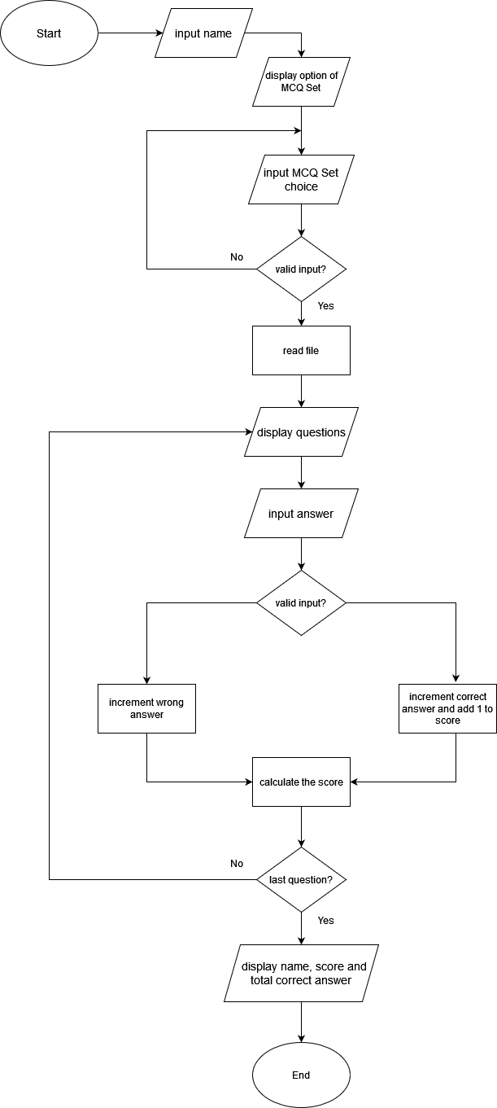

# Architecture

* Project (Folder)  
  Consist of all project files
* src (Folder)  
  Folder to store all the source code
* MCQ (Folder)  
  Folder to store all the CSV MCQ Set files
* Main (java class)  
  Main Class of the program
* MCQ (java class)  
  MCQ System program consist all the functionality of the program

# Implementation

**Step 1**

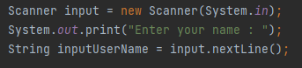

Taking user input using “Scanner”, user will be required to be inputting their name in the first time the program started.

**Step 2**

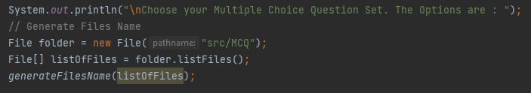

Using “File” Class imported from java.io.File, read all the files in the MCQ folder and get all the list of files, after that here we are using method called “generateFilesName” that given parameter of listOfFiles array.

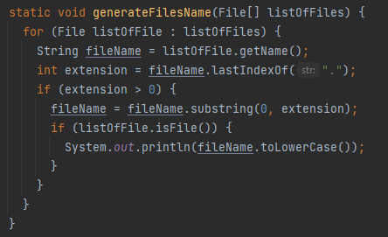

In the method “generateFilesName”, loop through all the files and print all the file name into the console without the extension.

**Step 3**

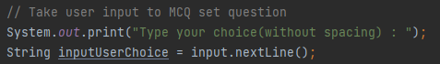

Taking the user input for them to selecting the MCQ

**Step 4**

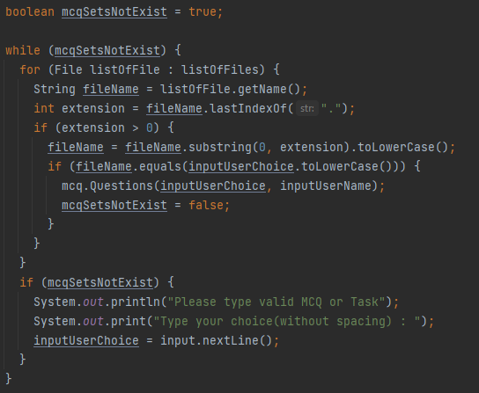

Cheking user input if they inputting invalid MCQ or Task

**Step 5**

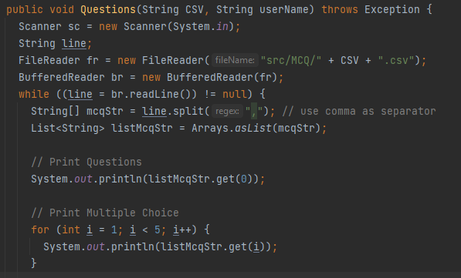

Displaying the question and the multiple choice according to user input after they select the MCQ or Task.

**Step 6**

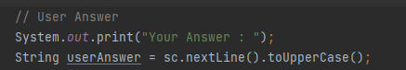

Taking user answer

**Step 7**

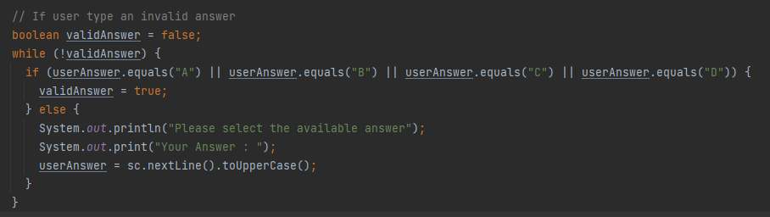

Checking if the user inputting valid answer or not

**Step 8 & 9**

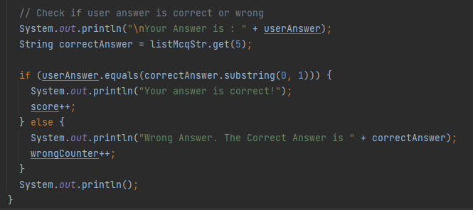

Comparing the user answer and the correct answer, if user choose the correct answer they will get 1 score

**Step 11**

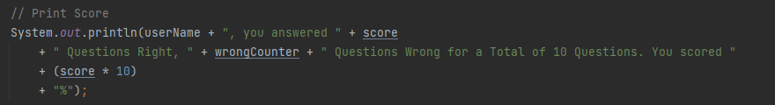

Printing user score and let them know how many answer they get correct and wrong.

**Debugging with Intelij IDEA**

Debugging with breakpoint helps to identify error better, in this case variable listOfFiles might be null and still running without error, so after debugging with the breakpoint the code will be repaired to make it more secure and robust applications.

